Marella Morad

72D
Quality Planning

Table of Contents
Introduction: 2
Quality Planning Actions: 2
Code Review: 2
Unit Testing: 2
Usability Testing: 2
Detailed Test Plan: 3
Participants: 3
Test Cases: 3
Tasks: 3
Metrics: 3
Test plan evidence in JIRA Board: 3

Introduction:
In this report, I will document my comprehensive plan to ensure the quality of the two metrics defined in 71D. The two metrics are as follows:
Metric | Threshold
Efficiency of Adding a Member. | The average time taken by users to add a new member should be less than 2 minutes.
System Recovery in Case of Member Deletion by Mistake. | The system should provide a "soft delete" feature, allowing users to recover deleted members within 48 hours by contacting IT Support.

Quality Planning Actions:

Code Review:
Since this feature was developed in Sprint 1, I already have evidence for conducting a code review. After I finished implementing this feature, I raised a Pull Request and requested review from my team members. I received a review from the Product Owner – Alexander Kyriacou as shown below:
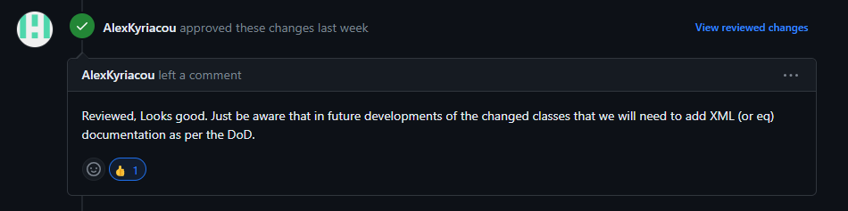
I had missed XML documentation which was one of the standards that we agreed on before commencing development. I added the relevant documentation before merging the changes into our main branch.

Unit Testing:
In Sprint 2, I am planning to develop unit tests to cover critical functions and components of the Member Management Web Pages task. In Sprint 1, I focused on getting the functionality working and relied on manual testing during development, without running any automated tests. Personally, I prefer using a test-driven development (TDD) approach whenever I'm developing a new feature. However, I believe it is important to also have unit tests, including cases related to adding members and retrieving soft-deleted members. These tests will enable me to check if the above-mentioned metrics have been met and will indicate if a change is required. For example, a performance boost may be needed, or there may be a mistake in the logic of retrieving records.

Usability Testing:
As part of Sprint 1, the tester in our team, Nelchael, performed a simple usability testing on these web pages and raised some concerns about appearance and functionality, and I tried to address most of them in Sprint 1. In Sprint 2, I’ll work on improvements to these pages, and I will write some test scenarios for Nelchael to execute that reflect real-world use cases, such as adding a new member and recovering a deleted member.

Detailed Test Plan:

Participants:
I will try to get all the team involved in this testing phase as these pages are very critical for the performance of our web application. I will seek help from the other developer in the team for better coding practices and performance boosting approaches. I will also ask the product owner, scrum master and tester for their feedback regarding different functionalities.

Test Cases:
Unit Test Cases: I will write some internal component (unit) test cases to validate code correctness and component behaviour.
- Test case examples: Verify member creation, test soft delete functionality, and recovery process.
Usability Test Cases: Developed in collaboration with product owner for a better insights and representation of the end user group.
- Test case examples: Add a new member, attempt to delete a member by mistake and recover within 24 hours, and navigate through the member management pages for efficiency.

Tasks:
I will write unit tests for the Member Management Web Pages task which includes the MembersDashboard.js, Member.js and AddMember.js pages. Then once these tests pass, I will move the task to Testing and assign it to our tester who will get a chance to execute the usability testing scenarios, document any issues and provide feedback or raise bugs as applicable.

Metrics:
- Unit Test Metrics: Pass/fail status for each unit test case.
- Usability Test Metrics: Measure task completion time, and user satisfaction, and identify usability issues.

Test plan evidence in JIRA Board:
